2 Question 2

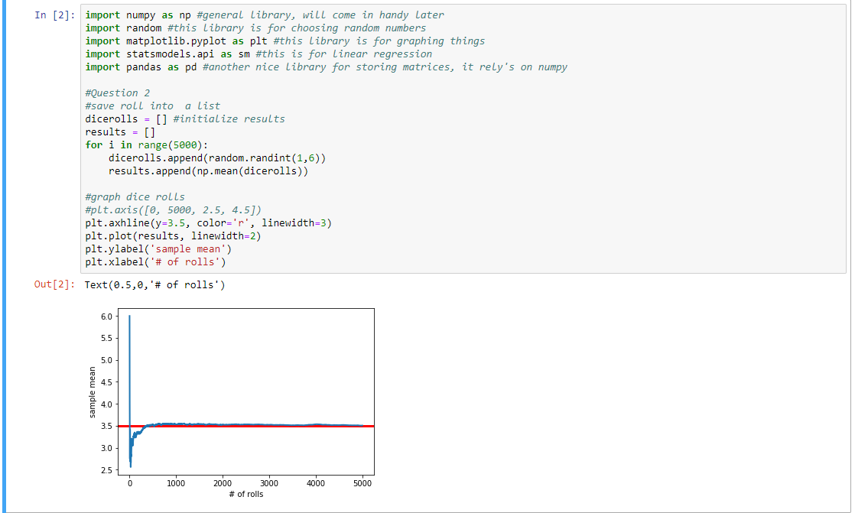

As sample increases, the sample mean converges to the population mean of 3.5

3 Question 3

1. 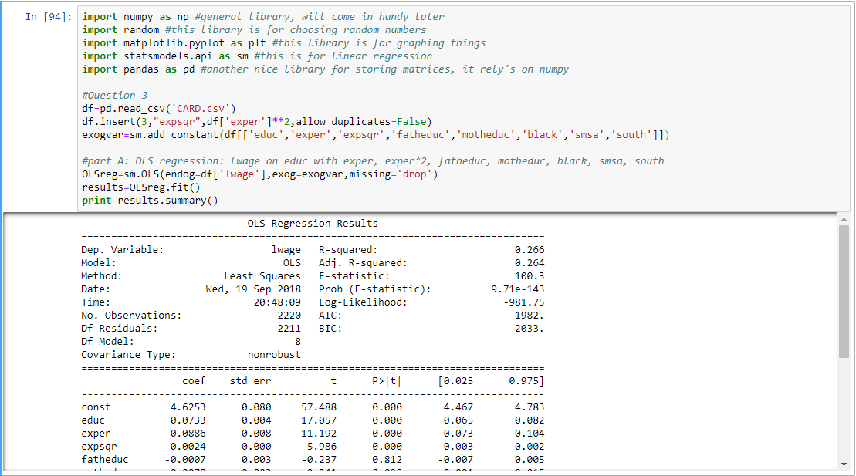  
   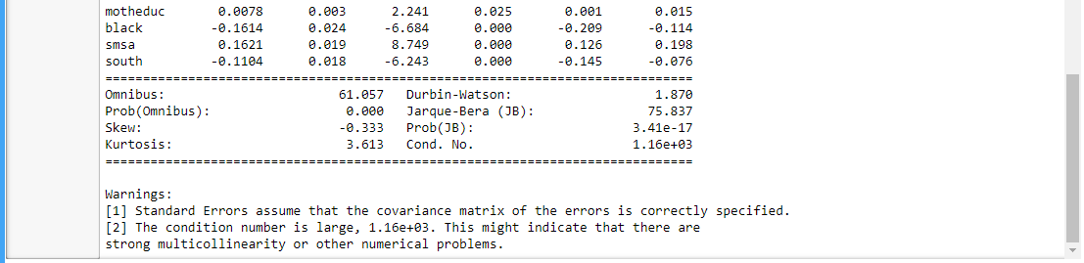  
   Here we see that educ has an effect of .0733 on lwage. Because the S.E(educ) is .004 and coefficient is well over 2x that amount, the result is significant.  
     
   NOTE: I believe that me running Python 2 would result in slightly different values than if I were on Python 3. I confirmed this with classmates who ran Python 3 for their OLS regression. I think it may have to do with the way division is done between the two versions.
2. The regression fails to control for inherent ability or ambitions so there is selection bias in the estimations.
3. i) Proximity to college meets the exclusion restriction since those from less wealthy backgrounds would be more likely to attain an education since it is closer and therefore less costly. Proximity to college is also randomly assigned because an individual’s proximity to college is determined independently of unobserved traits and control variables.   
     
   ii) 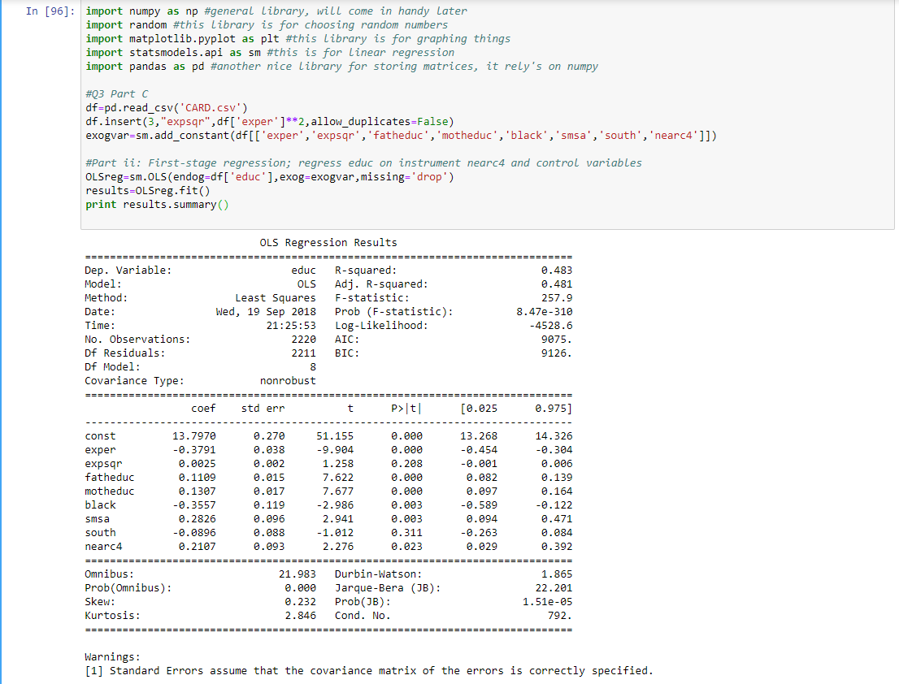  
   The instrument has a significant effect on education since its coefficient is over 2x the SE(nearc4). Thus, there exists a first stage effect.

iii) 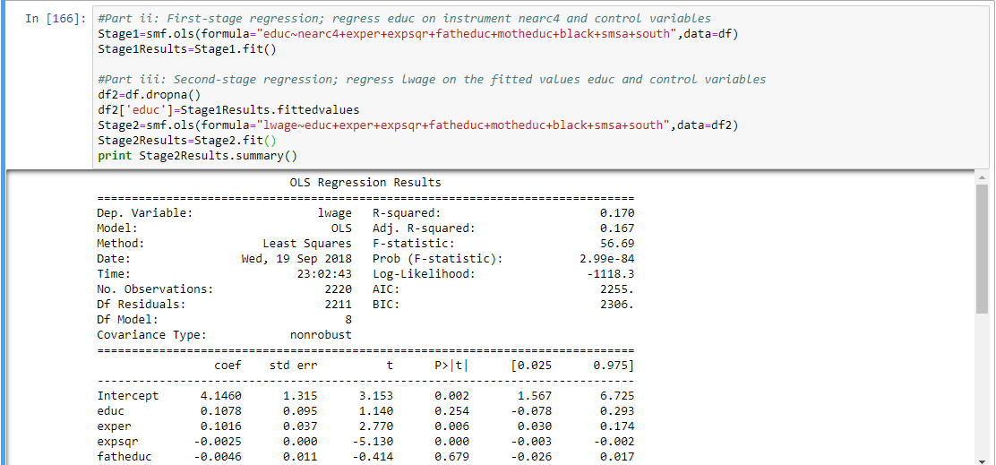

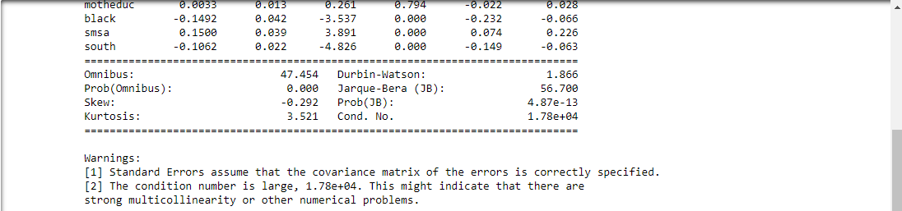  
The 2SLS estimate of educ on lwage is .1078. This is an increase from the OLS estimate of .0733  
  
iv) See back of lined paper for calculation.